1.First page

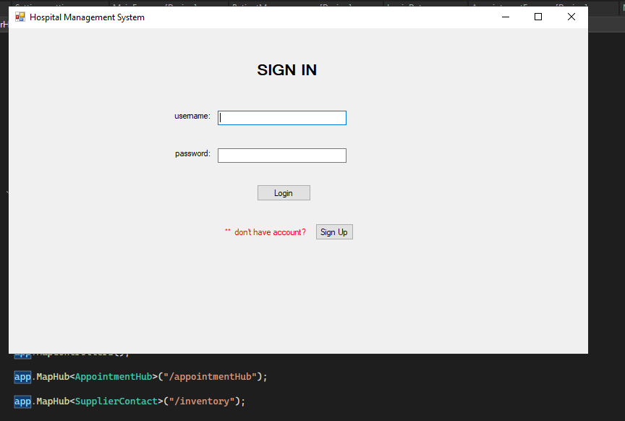

2.Sign Up

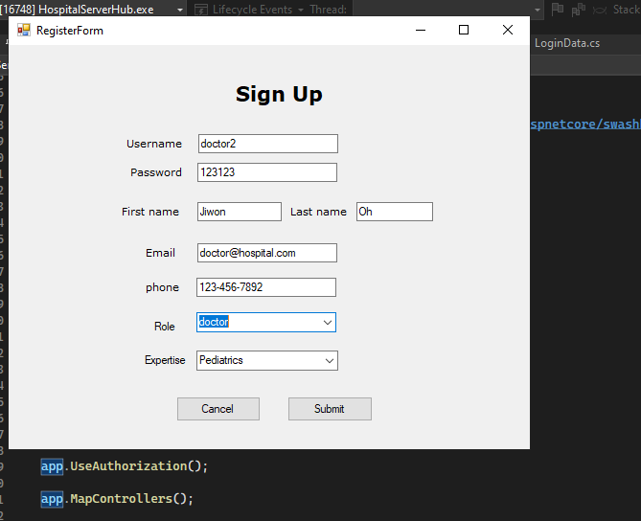

3.Login

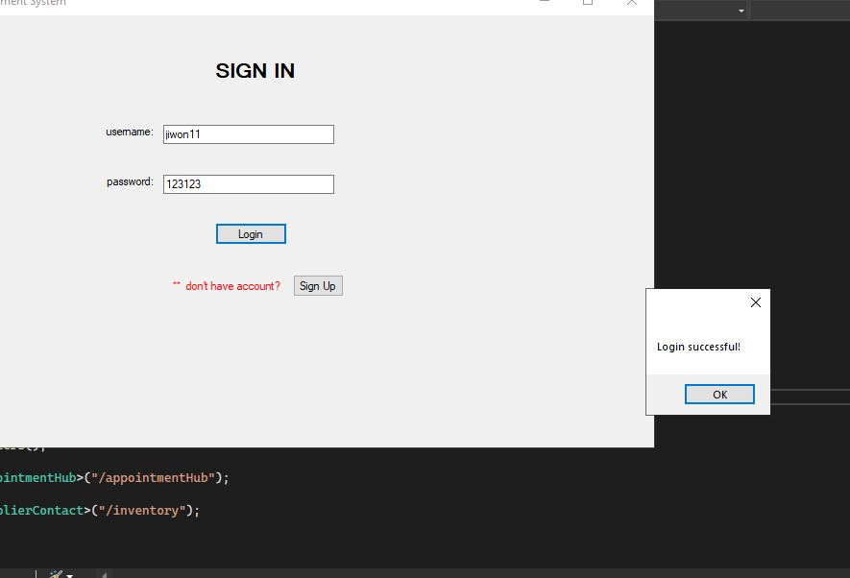

4.Login as doctor, nurse and patient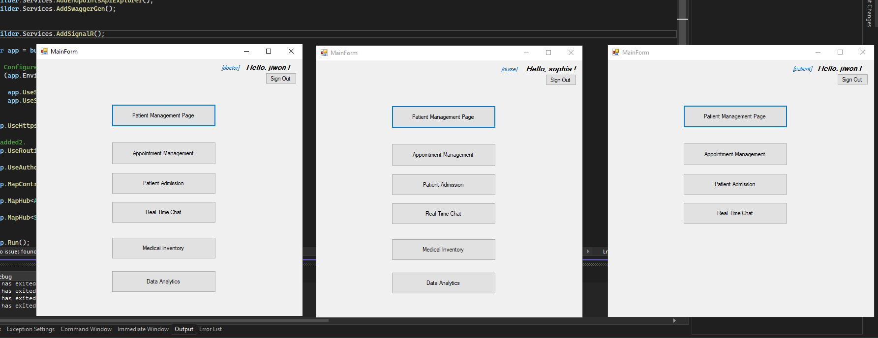

5. Patient Management page as doctor /nurse/ staff vs Patient 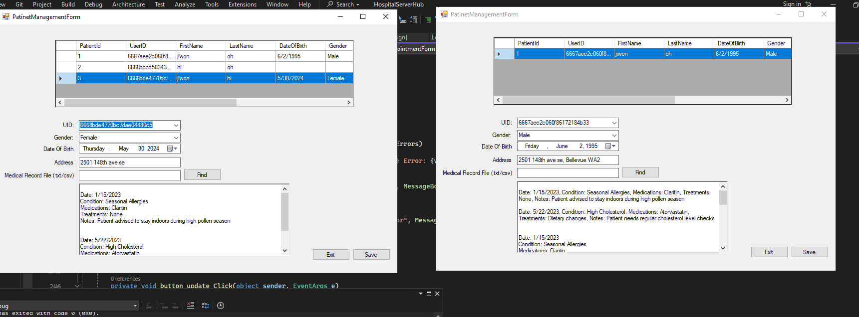

6. file search and get medical history data from file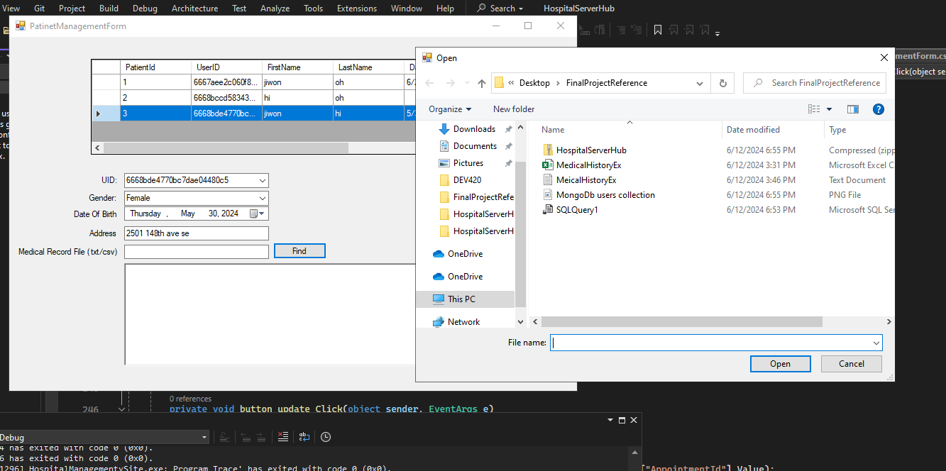

7. update patient information

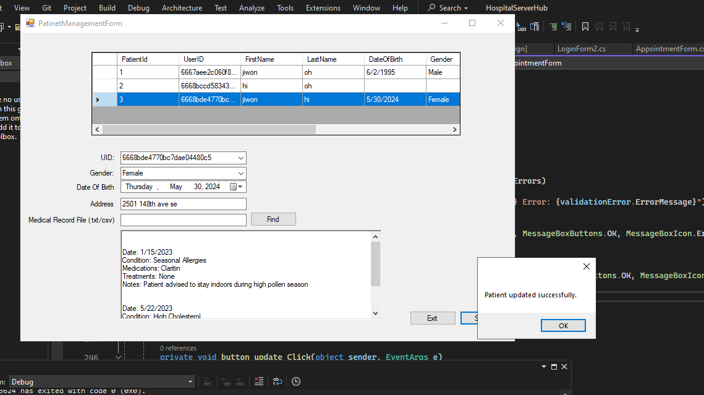

8.Appointment Management (login as doctor, nurse and patient)

8.1nurse make appointment

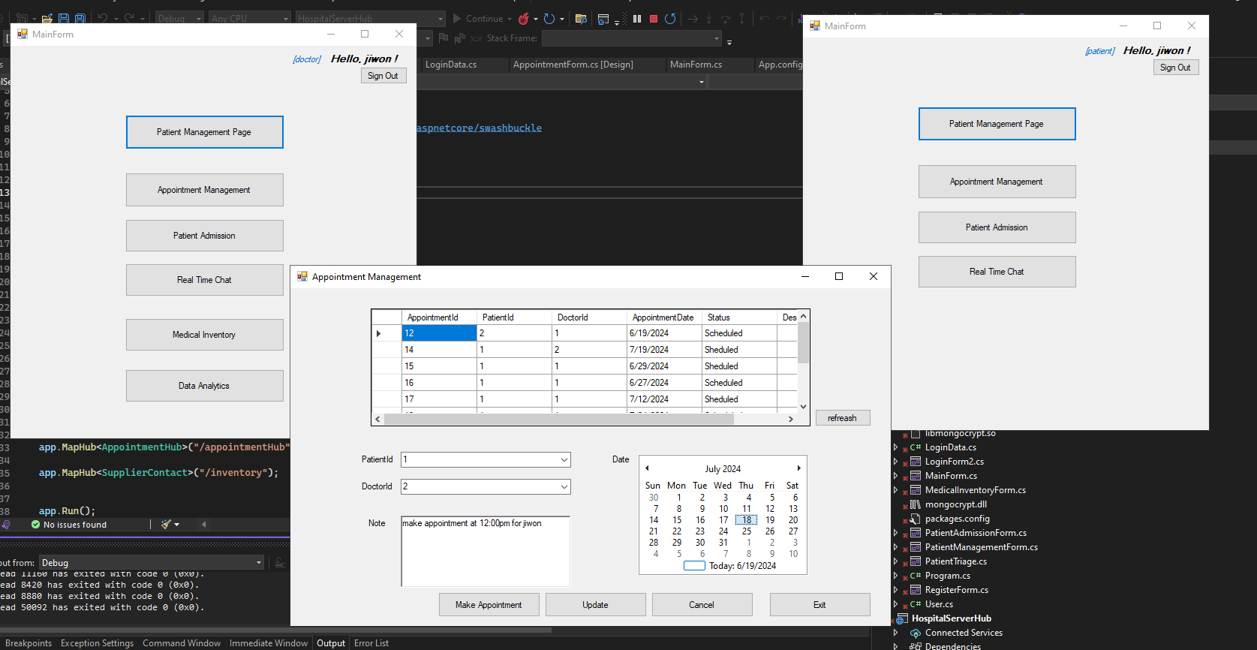

8.2. related doctor and patient get update message

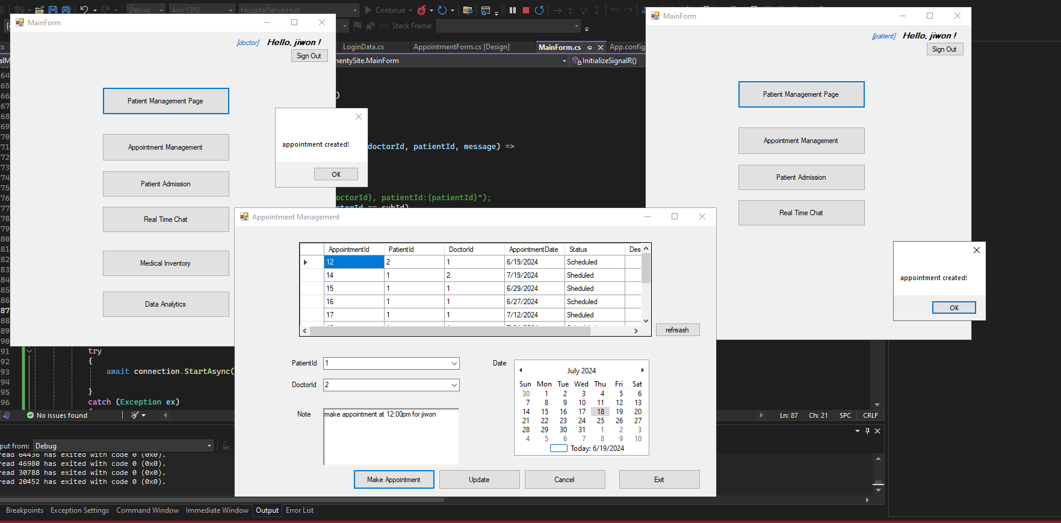

9. appointment cancellation update 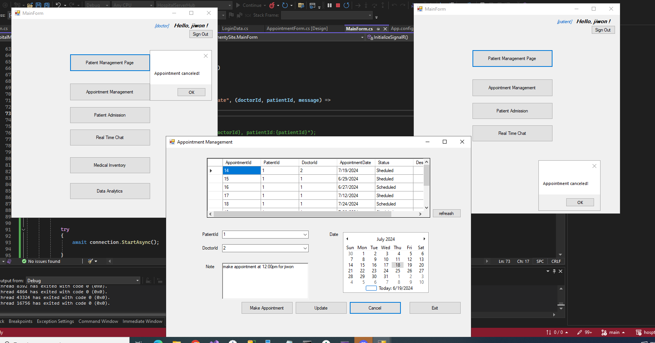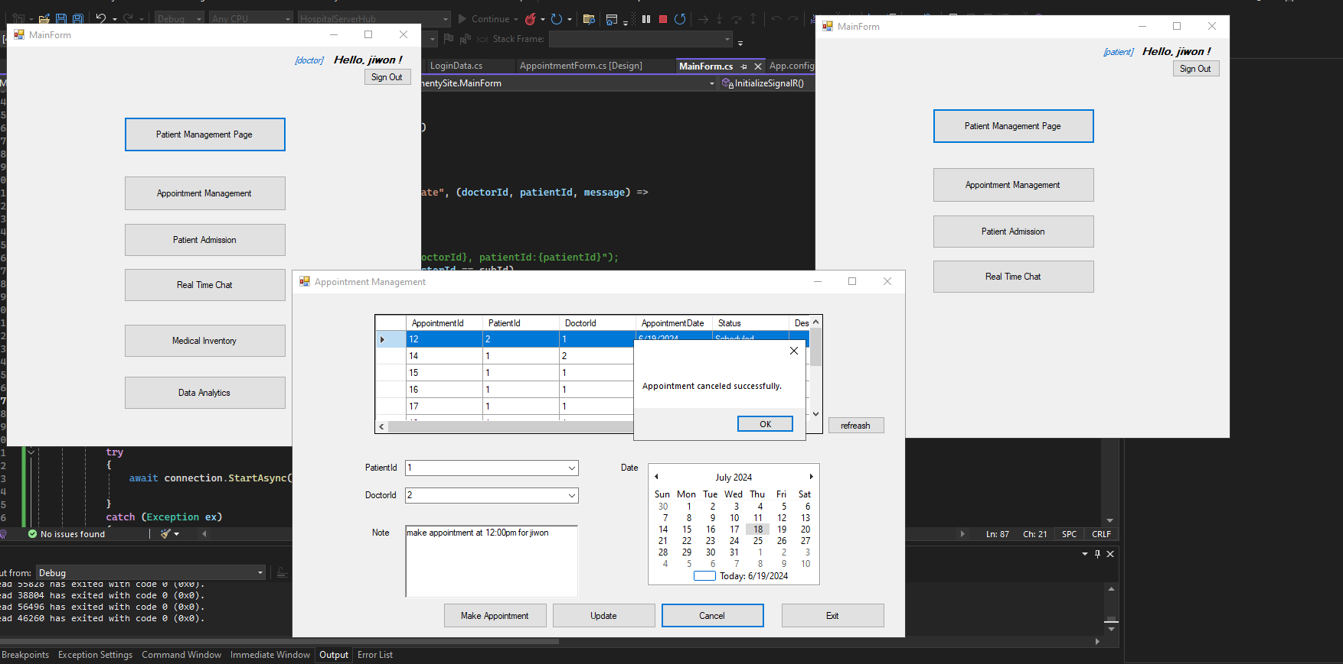

10. Steps to admit new patient

a. Click on Patient Admission and Monitor.

b. Click search button to load all patients.

10.1

a. Select patient for triage (PatientId 1)

b. Click on “Triage Patient” button and Patient Triage Form pops up.

c. Select two combo box choices for visit reason and patient status.

d. Click on the submit button and “Patient’s Vital Signs” is pop up.

10.2

Enter normal vital signs for patient.

10.3 Admit patient to ER and send code red alert when patient is in critical condition

a. Change patient status to ICU or ER admission

b. Update patient’s vital signs with critical conditions (*Critical heart rate is below 40 or above 150. Critical body temperature is above 110oF)*

c. Code red alert is displayed on list box.

11. Real time chat using signalR

Navigates both users to “Real Time Chat” Button

Enter a message and click send button for both side

12. Medical Inventory using signalR

12.1

a. Login as doctor and staff and navigate to medical inventory

b. Click on load button to load up all the item

c. Click on each cell to load all text in the textbox

d. Change the quantity with value to consume band aid.

e. A message pops up for staff to let them know item’s quantity is running short. (This happen when quantity is below 100)

12.2

a. Click to load item on staff form (right side)

b. Click on each cell to load all text in the textbox

c. Restock item quantity on the Quantity textbox with value bigger than 100

d. Reload item on doctor form to see the restock item

13. Data Analytics

13.1

Login as staff and nagivate to Data Analytics

Patient visits:

1. Select “Patient visit” from combo box.
2. Choose time interval for most visit from patient
3. Click search and visit date with most visit appear in the datagridview as well as message box pop up for description

13.2 Common aliment

a. Select “Common aliments” from combo box.

b. Choose time interval for most common ailments

c. Click search and the most common aliments will display in the datagridview as well as message box pop up for description

13.3 Medication usage

a. Select “Medication usage” from combo box.

b. Choose time interval for most medication usage

c. Click search and the most medication usage will display in the datagridview as well as message box pop up for description

